K2 Audio Single Board Computer (BeagleBone Black)
Audio Control Panel Configuration Document

TABLE OF CONTENTS
TITLE i
TABLE OF CONTENTS ii
GETTING STARTED 1
SSH CONNECTION TO BEAGLEBONE 1.1
REPOSITORY STRUCTURE 1.2
MODULE DOCUMENTATION 1.3
RUN OPTIONS 2
SETTING RUN CONFIGURATIONS 2.1
CHANGING IP ADDRESSES AND/OR DHCP SETTINGS 2.2
RUNNING MANUALLY 2.3
PANEL_MAIN SERVICE 2.4

1 - Getting Started

  - - SSH Connection with Beaglebone

Connection with the Beaglebone is neccesary to change any run configuration or change IP addresses. Although the system is meant to be run automatically, these configurations may change depending on the system and/or network. To access the Beaglebone via SSH do the following:

If on a Windows PC, download putty at the following link:

https://www.chiark.greenend.org.uk/~sgtatham/putty/latest.html

Run Putty and at the default screen enter the host name of the Beaglebone or IP address as shown:

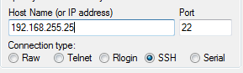

Click open, and login with the Beaglebone credentials provided. In the image below the credentials are the default with u/n: debian, p/w: temppwd. To access the K2_Audio repository run the following command:

$ cd K2_Audio/

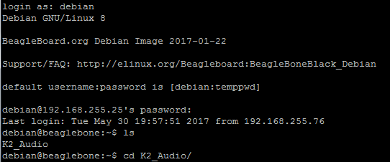

  - – Repository Structure

The K2_Audio repository structure is contained in one directory, with all used modules falling under the top K2_Audio/ directory. The Beaglebone K2_Audio/ directory is of the following structure:

- /home/
- debian/
- K2_Audio/
      - panel_main.py
      - run_configs.py
      - unsolicited_utils.py
      - message_utils.py
      - globals.py
      - button_led_map.py
      - command_map.py
      - tests.py
      - K2_logging.log

  - - Module Documentation

All module documentation is served through static html files on an Apache server on the Beaglebone. This documentation can be seen at the Beaglebone’s IP address (shown as 192.168.255.25) followed by module name html if connected within the same local area network. The documentation for these modules is a brief description of what the each method does, the parameters required and the returned variable(s).

panel_main.py -> http://192.168.255.25/panel_main.html
unsolicited_utils.py -> http://192.168.255.25/unsolicited_utils.html
message_utils.py -> http://192.168.255.25/message_utils.html
run_configs.py -> http://192.168.255.25/run_configs.html
globals.py -> http://192.168.255.25/globals.html
button_led_map.py -> http://192.168.255.25/button_led_map.html
command_map.py -> http://192.168.255.25/command_map.html

2 - RUN OPTIONS

2.1 – Setting Run Configurations

The main module that has a command line interface and is run by default by the system is panel_main.py. This module can be run either with command line arguments or a configuration file. By default, it is run with a configuration file within the systemd service. Running panel_main.py with these configurations requires the --f or --CONF_FILE flag to be set to True (see 2.3 – Running Manually ).

An example of this file is as follows:
config_dict = {'host': '0.0.0.0',
'port': 8003,
'tcp_client': True,
'startup_sequence': False,
'client_host': '192.168.255.76',
'client_port': 7477,
'debug': True}

To edit this configuration file run the following command:
$ sudo nano /home/debian/K2_Audio/run_configs

Host – host IP to run the server on, (default is ‘0.0.0.0’ to be seen externally)
Port – port to run the server on
Tcp_client – Run connect on tcp client, (default True, only not used for testing)
Startup_sequence – Run initial lighting sequence and hold until a connection has been made, (default True, only not used for testing)
Client_host – DSP server IP address
Client_port – DSP server port
Debug – set global DEBUG true or false (useful for running locally to see stdout statements)

  - - Changing IP Addresses and/or DHCP Settings

The Beaglebone can have either a DHCP chosen IP address, or a set static address. To maintain consistency, we developed the board with a set static IP address to host a TCP server, and allow the DSP client to connect to a known host. The main configuration file in Linux which enables/disables DHCP and allows setting static IP addresses is /etc/network/interfaces.

To enable DHCP, comment out all lines shown in figure 2 below, and uncomment iface eth0 inet dhcp.

To edit this static IP address run the following command, and use figure 1 as a reference:
$ sudo nano /etc/network/interfaces
Change address and gateway to IP address and network gateway (router):
Example: if static IP should be 192.168.200.218, gateway should be 192.168.200.1, figure 1 has a static IP of 192.168.255.25, and a gateway of 192.168.255.1

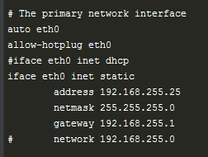
Figure 1: Example screenshot using static IP of 192.168.255.25

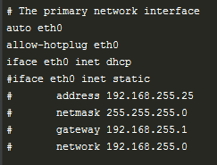
Figure 2: Example screenshot using DHCP for eth0

After these files have been changed, reboot the Beaglebone or power cycle the unit.
To check if the changes have taken place, run the following command:

$ ip addr

And check if eth0 has the designated IP address you set, or an IP set by DHCP.

  - – Running Manually

Although there is a service which runs the program when the Beaglebone boots up (see 2.4 – Panel_main Service), the main program can be run directly through the command line. Panel_main.py is the main module which runs from a command line interface, and can be run with either command line arguments or a run configuration file (see 2.1 – Setting Run Configurations). NOTE: panel_main.py MUST be run using sudo because of permissions with GPIO port file descriptors.

To run with specific command line arguments and not a file, the command line arguments must be present or else there will be default values injected. The following figure shows the arguments, defaults and help for each command line argument:

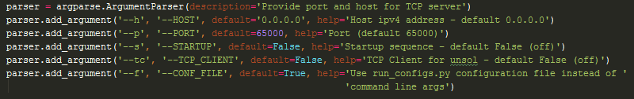
Either style of argument can be used, for example, --h or --HOST can be used to set the host IP.

An examples of running from command line is as follows:
$ sudo panel_main.py --h 0.0.0.0 --p 5600 --s True --tc False

Panel_main.py can also be run using the configuration file described in 2.1, and can be run as follows:
$ sudo panel_main.py --f True
or
$ sudo panel_main.py --CONF_FILE True

  - - Panel_main Service

To allow the main process to continuously run without faults, and restart when necessary, there is a systemd process that is enabled and can be configured. This starts on boot, and can be configured to restart after a certain time. The file is located at /etc/systemd/system/panel_main.service

To edit this file:
$ sudo nano /etc/systemd/system/panel_main.service

On this system, we have panel_main.py being run on boot when the system gets the point of being idle, and will always try a restart when the process has failed after 3 seconds. The following image shows the panel_main.service systemd configuration file:
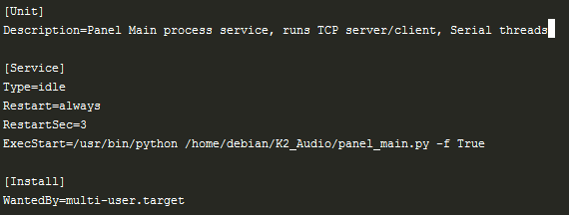

To see the status of this process run:
$ sudo systemctl status panel_main.service

To reload the service after making changes to the file run:
$ sudo systemctl daemon-reload

To check if the process is running on the system run:
$ ps aux | grep python

and look for /home/debian/K2_Audio/panel_main.py process.

